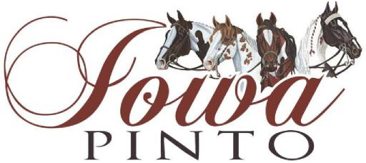
Iowa Pinto Horse Association Sponsorship/Advertising Information
We would like to offer you the opportunity to sponsor by donating a minimum of $50 to be an Iowa Pinto Sponsor or advertiser. We have 4 shows each year.
$50 sponsor benefits include:
Name announced once a day at all 4 shows.
Name and/or logo on our Website : www.iowapinto.com
Recognition at our annual banquet

$100 or more sponsor benefit include:
Name announced multiple times at all 4 shows.
Name and/or logo on our Website: www.iowapinto.com
Name and/or logo in our club newsletters as well as one time ad. These are published 3-4 times a year
Recognition at our annual banquet

Date: Amount:
BUSINESS/Web site:
CONTACT NAME:
ADDRESS:
CITY/STATE/ZIP: PHONE: ( )
Sponsorship obtained by Iowa Member:
Return the completed form with your payment to Iowa PtHA:
Iowa Pinto, 6289 Gear Street, Prole, Iowa 50229
Thank you in advance for your consideration!

