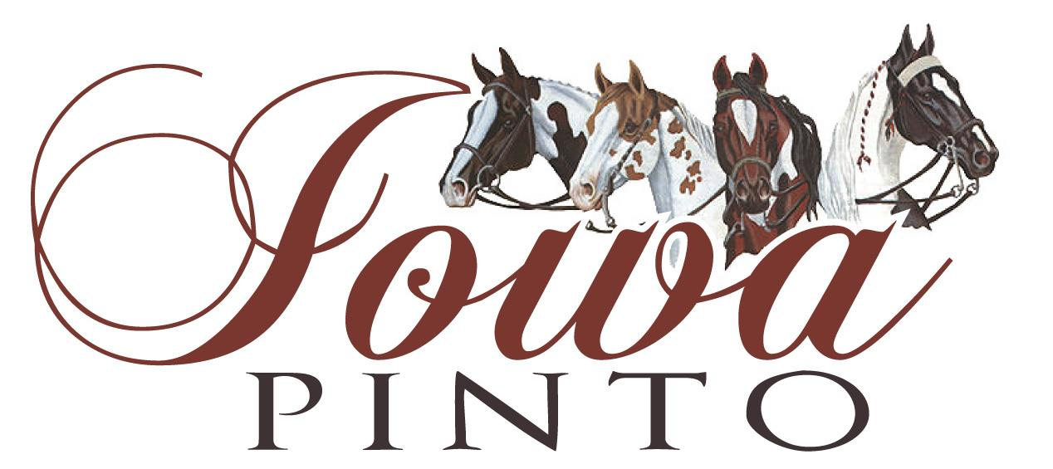

MVP- Most Valuable Person

Criteria

- Goes above and beyond for Iowa Pinto.
- They are friendly, inclusive, and volunteer wherever they can without being ask.
- Step up to assist when needed
- Promote Iowa Pinto and Pinto to others
- Support their peers and represent the ideal Pinto member

Who qualifies:

- Nomination by name and a brief summary of why the individual is nominated
  - Mark Timke- Treasurer Iowa Pinto
6289 Gear St
Prole, IA 50229
- Nomination may be from self or another Iowa Pinto Member
- Can be a board member, Iowa Pinto member or show staff

Deadline:

- December 15
- Will be awarded at the annual banquet

