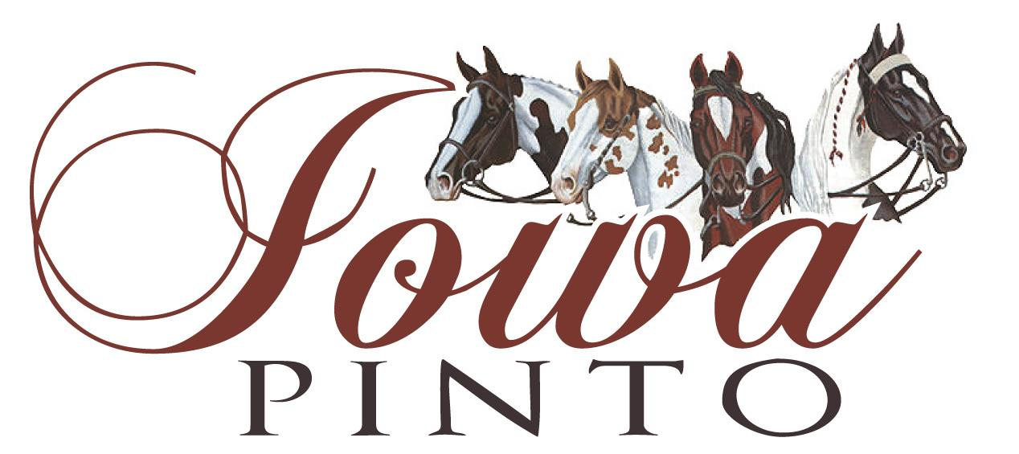

Iowa Pinto Point System & Rules
- Owner or lease and exhibitor of horse/pony/mule/donkey must be current members of Iowa Pinto prior to showing in any eligible class.
- Any violation of National Pinto rules and/or Iowa Pinto rules shall result in disqualification for any weekend or year-end awards.
- To be eligible for year-end awards must show at minimum of half the shows offered that year. Example if 3 shows are offered – must show at 2 shows. If 4 shows are offered must show at 2 shows.

Point Scale:
Entries 1st 2nd 3rd 4th 5th 6th
1 1
2 2 1
3 3 2 1
4 4 3 2 1
5 5 4 3 2 1
6 6 5 4 3 2 1
7 + 7 6 5 4 3 2 1- each exhibitor in class receives 1 point after 6th place
**No points are awarded for Grand or Reserve Champions in Halter

16 Weekend High Point Categories

- Youth 10 & Under W/T
- Youth 11-18 W/T
- Youth 13 & Under
- Youth 14-18 pinto
- Youth Solid 18 & U
- Novice Youth 18 & U
- Youth ABO 18 & U
- ABO 19 & Over
- AM W/T
- AM Jr
- AM Sr/Elite
- Nov AM
- Open Pinto
- Solid AM/Open
- Ranch Horse
- Long Ears

Year End Awards

- All Around Youth 10 & Under W/T
- All Around Youth 11-18 W/T
- All Around Youth 13 & Under
- All Around Youth 14-18 pinto
- All Around Youth Solid 18 & U
- All Around Ranch Youth 18 & U
- All Around Novice Youth 18 & U
- All Around Youth ABO 18 & U
- All Around ABO 19 & Over
- All Around AM W/T
- All Around AM Jr
- All Around AM Sr/Elite
- All Around Nov AM
- All Around Open Pinto
- All Around Solid AM/Open
- All Around Ranch Horse AM/Open
- All Around Long Ears
- OEB Yearling- Champion and Reserve Champion
OEB 2 and Older- Champion and Reserve Champion
- Yearling Triad- Champion and Reserve Champion

14 Pinto Division Hi Points
- Ranch Pleasure/Riding
- Trail
- Halter
- Color
- Longe Line
- Showmanship
- Ideal Pinto
- Western Pleasure
- Horsemanship
- Discipline Rail
- Western Riding/Reining
- Driving
- Hunter Under Saddle
- English Equitation

In addition, Iowa Pinto gives out a MVP award and Rookie Member of the Year award.

