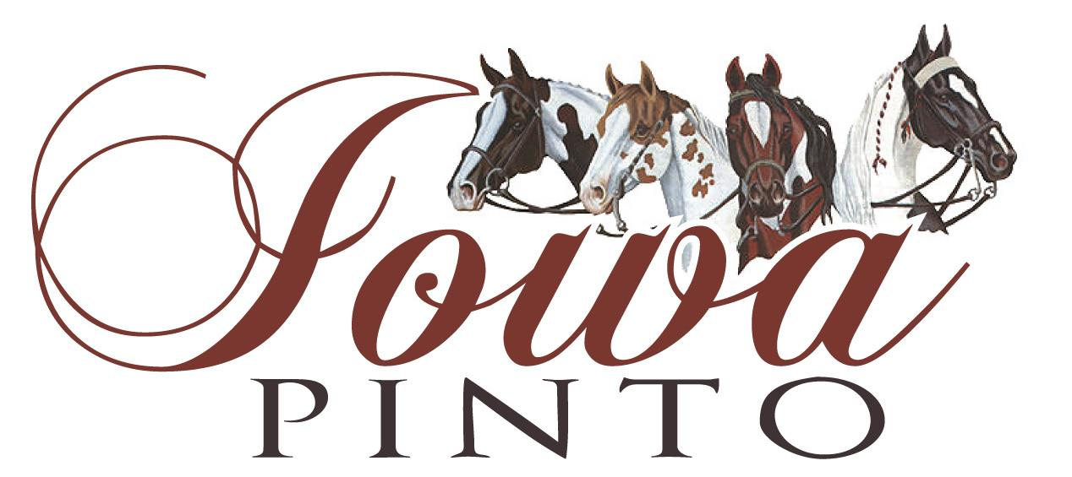

Timke Family Show Sponsorship

Purpose:

- This sponsorship is design to help defray cost to attend a show.
- Assist in promoting Pinto to newcomers
- Demonstrate the importance of kindness and giving to others

What:
- One-night hotel room and taxes paid for at AmericInn (Value $125)

Who qualifies:

- Nomination by name and a brief summary how this would benefit the individual (in 200 word or less) to be submitted to:
  - Mark Timke- Treasurer Iowa Pinto
6289 Gear St
Prole, IA 50229
- Nomination may be from self or another Iowa Pinto Member
- Do not need to be current Iowa Pinto member to be nominated

Deadline:

- June 30, 2020
- Will be awarded prior the July Iowa Pinto show

