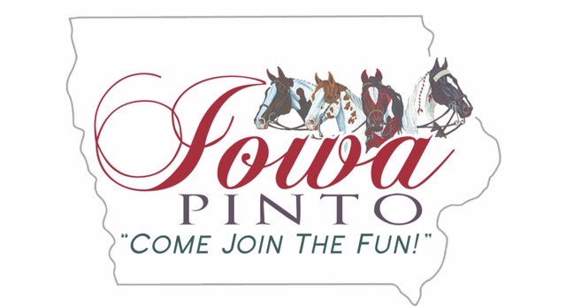

2020 Iowa Pinto Horse Association Membership Application
All expires 12/31 in current year
Single $20 / Family $30 / Youth $15
New______ Renewal_____

Primary Member Name:_______________________________________________________

PtHA Member ID:______________________ Iowa Member ID:_______________________

Spouse Name:_______________________________________________________________

Spouse PtHA Member ID:_____________________ Amateur _______________________

Address:____________________________________________________________________

City:_ __________________________________ State:___________ Zip:_________________

Home Phone:___________________________ Cell Phone:___________________________

Email:_______________________________________________________________________

By checking this box, I/We authorize the Iowa Pinto Horse Association to send me email and text message updates.
I/We agree to abide by the rules of the Iowa Pinto Horse Association. All information given is true, correct and complete.

Signature:________________________________________________ Date:______________

Iowa Pinto Horse Association Youth Membership Application
Name:_____________________________________
PtHA ID:______________ DOB:________________

Name:______________________________________
PtHA ID:______________ DOB:________________

Name:______________________________________
PtHA ID:______________ DOB:________________

Name:______________________________________
PtHA ID:______________ DOB:________________
Office Use:
Check #__________________
Amount__________________
Date Received:____________
Card Mailed:______________

Return with payment to:
Angela De La Riva
2974 330th Street
Ellsworth, IA 50075

